## GAME DESIGN DOCUMENT – VR LAB TRAINING WET LAB

**Game concept**

The virtual labs are fully interactive training simulations in which students perform experiments in a wet lab, collect data, and answer questions to assess their understanding. The labs combine animations, illustrations, and videos to convey key information and engage students in the process of science.

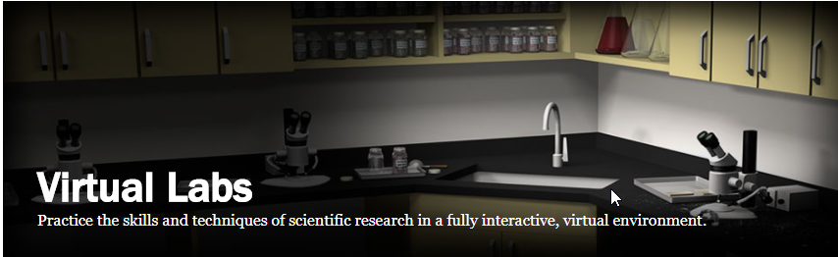

**Target platforms**

* Unity’s native VR (VR Standard Assets)
* Cross-platform: all main platforms (HTC Vive and Samsung Odessey (WMR)
* Desktop VR
* Seated/standing up experience

**UI**

* Reticle (gaze-based input) and Controller Interactions
* 3D Panels, text, buttons
* Progress Indicators

**Game mechanics**

* Video will be playing and it will be paused when instruction is given
* Instructional Video/Animation directs the user to perform an action
* The user has to perform the highlighted action, they will get response and move on
* After performing the action that has been given the video/animation will continue playing to next action
* All equipment in the lab will be interactive
* At the end of the training you will be notified and see your score
* Interactive Particles Effects controlled by knobs and buttons

**Assets**

* 360 video
* Questions / answers (will come from URL)
* Reticle / VR Standard Assets
* Panels
* 3D Web Lab
* 3D Lab Equipment Interactive